Introduction

The OwlEval system is designed to collect web-based course evaluations, and provide a secure interface for faculty to change evaluation questions and view reports of collected evaluations. The student portion of the OwlEval system is where the evaluations are actually collected
This portion of the OwlEval system is designed to have a student enter a key, be presented with an evaluation corresponding to that key, fill out the evaluation, and save it. It must handle erroneous data entry, and entry onto a page outside of the standard flow.

Relationship to Other Documents

We have broken the OwlEval system into five components:

- Student evaluation completion
- Faculty login and reports viewing
- Evaluation augmentation
- Evaluation creation and key generation
- Database access

This document focuses on item 1. Accordingly, there will also be test cases for each of the other items.
System Overview

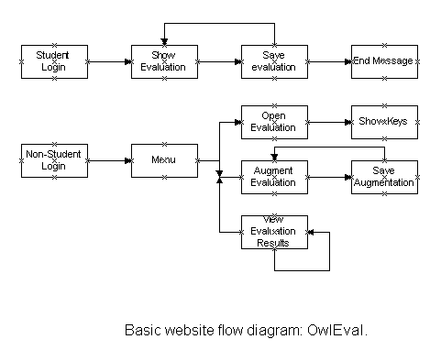
Above is a web-flow diagram for the OwlEval system. There are two distinct branches: Student and Faculty. Either Student or Faculty will enter the system from the left of the diagram and proceed through options until they have satisfied their desire to interact with the system.

Features to be tested/not to be tested
Feature | Location | Desired outcome
Login using key | Student login | Evaluation is presented
Fill out evaluation | Show Evaluation | All options are presented correctly and in order, and all presented options represent every option from the correct evaluation.
Key locking | Show Evaluation | If a key is used to access an evaluation, it must be tagged as “locked” with a timer.
Key Destruction | Save Evaluation | If an evaluation is saved, the key that corresponds to it is destroyed
Save evaluation | Save Evaluation | Erroneous input is detected and reported back to the student. If no erroneous input, then the evaluation is saved

Pass/Fail criteria
Feature | Pass Criteria | Fail Criteria
Login using key | Correct evaluation is displayed | Any browser page error.  Failure to report back to the student exactly what error may have occurred in the system.
Fill out evaluation | All items of the correct evaluation are displayed.  All items have correct options for answer. | Any browser page error.  Items not belonging to the requested evaluation or not all items on the correct evaluation are displayed.
Key locking | Key is locked if available, and error message is displayed if the key is already locked or not in existence. | Any browser pager error.  Permission to lock an already locked key.  Attempt to lock a non- existent key.
Key Destruction | Key is destroyed after a successfully saved evaluation | Any browser pager error.  Attempt to destroy an already destroyed key
Save Evaluation | All items on the evaluation are successfully transmitted to the DB for archival | Any browser page error  Not all items get transmitted or transmitted incorrectly.  Meaning of any saved item is altered in any way.

Approach

To test these features, the basic page framework will be constructed with external variables assumed and proper. Each feature will be constructed and verified with all feasible inputs in an attempt to crash the system.

Suspension and resumption
Since each page must complete processing before it is displayed to the user (because it will be written in PHP), any error condition must be noted and displayed as part of the normal page processing routine. Suspension and resumption will generally be handled in this way.
Testing materials (hardware/software requirements)
One PC with PHP and MySQL installed locally.

Test cases
Feature | Test | Desired outcome | Outcome
Login using key | Enter some unrelated string | Present error
Login using key | Enter actual key | Present Eval
Login using key | Submit NULL | Reload login page
Fill out evaluation | Change all items | All items present
Key locking | Check DB for successful lock | Lock is good
Key Destruction | Check DB for key existence | Key should not exist
Save Evaluation | View saved information and compare against what was meant to be saved | All information should be saved correctly
Security | Enter site from somewhere other than login page. | Redirect to login page

Testing schedule
When the testing phase is entered, the features will be tested over the period of one week in the order of the test cases table.

